Project Stork Inc.

Event Vendor Contract

Cost: $25.00

Fees are NON - REFUNDABLE as they are used to promote the event.

Tables and Chairs will be available to vendors

Our event will last from 2pm-5pm

If needed, you may come to set up at 12:30pm

Event Details:

High Tea Fundraiser Event – Benefitting Project Stork Inc.

Date: May 6th, 2018

Location: Genesee County Park

11095 Bethany Center Rd, East Bethany, NY 14054

Time: 2pm – 5pm

Questions: (585) 590 - 6626

 ---------------------------------------------------------------------------------------------------------------------------------------------------

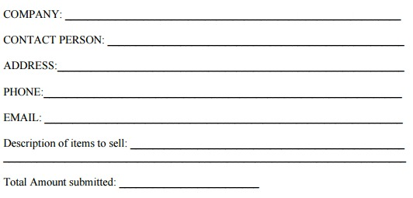

Signature: _____________________________________________ Date:__________________